

Lucas E40 Tube Light LightStreet Light Bulb

These light bulbs are made of CREE® XLamp® XRE high power LED and can be used indoor or out door applications and Easy to retrofit virtually any lamps that are designed with the E40 lamp holders.

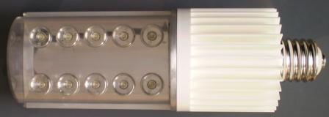
Figure 1 Front View

We have researched and developed a better performing E40 Lamp replacement. Only 15 Watts and you can replace the 1000 Lux Sodium lamps today using our standard model. Furthermore, with out increasing the power we can achieve higher out put of light intensity, by only replacing the LED chips from Q2 (87lm/W) to Q5 (120lm/W) and beyond.

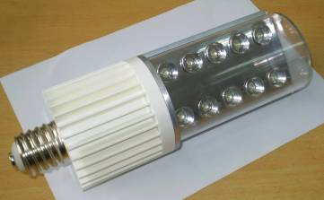
Figure 2 Side view with clear plastic cover

Lucas E40 Technical Specifications:

E40 type socket
Number of LEDs is only 10
Maximum power consumption: 15 Watts - includes LEDs, Drivers and Power Supply.
(DC version available upon request)

Maximum light output: >1000 lm

Cool White (5000~7000K) or
Warm White (3000-4000K)
Coverage: 90° cone shape. Perfectly distributed light beam
Life cycle: 50,000 hours
Operating Temperature-30°C ~ 40°C
Input Power 85 - 265VAC (universal)
Lamp housing material: Aluminum Alloy, PC
Recommended Heights: 4, 5 or 6Meters
Measured Illumination (E) (Height=4.5m) ->13 lux
Effective Illuminated Area Height is equal to the radius of the coverage area

IP Rating is: IP 58

Approvals: comply with all RoHS requirements. CE and UL pending

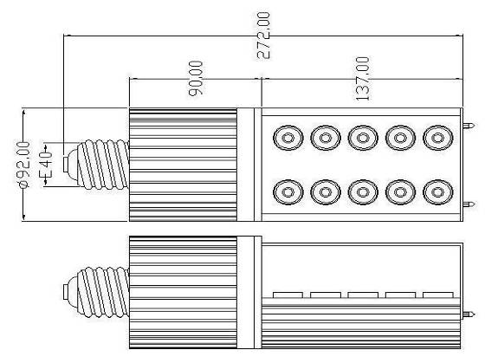
Figure 3 Technical Drawing and dimensions

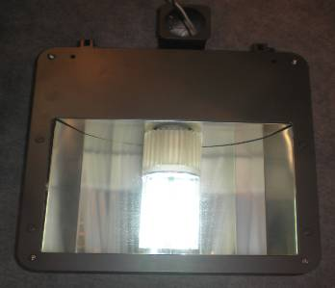

Figure 4 Lucas E40 tube light is shown here inside generic incandescent lamp housing.

Characteristics of our E40

- We use CREE® LED chips for highest light output and reliability.
- Very low total power consumption: Only 15 Watts!
- High Lumen output: >1000 Lumens.
- Internal current is only 330mA.
- Evenly distributed Circular Light Beam. Using our patented reflector cups we have achieved the most economical way to control light.
- Fits All Standard E40 Sockets, A Direct Retrofit Replacement:
- Easy assembly and Disassembly mechanism.
- Changing Power Supply made easy, you don’t need complicated tools to open the case and swapping a new power supply. .
- Smart Heatsink holds it all together using 2 long screws and maintain highly efficient thermal management
- Less visual fatigue when used with glossy shade.
- No need for “Very Hot” warnings
- No more cleaning.
- Global Power input: Use it in any country. 80VAC to 260VAC.
- Line frequency: 45Hz to 65 Hz
- No Ultraviolet (UV) or Infrared (IR) Radiation
- Shock-resistant: No moving parts or delicate filaments or breakable glass.
High precision Driver Board made of National Semiconductors LS3406 Chips to provide constant current and extend the life time of the LEDS.
- RoHS approved and certifies to be no poisonous substance, no Pb no Hg.
- Energy saved over 6 months will pay for lamp it self.
- Long lasting: guaranteed to provide over 70% of its original luminance for 50,000 hrs.

Why CREE?

Please read this to understand why we are using CREE® XLamp® XRE LED original package chips.

The CREE's XLamp® XRE LED is leading the LED lighting revolution with its unprecedented lighting-class brightness, efficacy, lifetime and quality of light. These lighting-class features enable the XLamp® XRE LED to replace many traditional light sources and save money with energy-efficient light and long lifetimes. Cree's advantage is in the materials they use. CREE® LEDs combine highly efficient InGaN materials with proprietary G•SIC® substrates to deliver superior price/performance for high-intensity LEDs. Typical features of CREE® LEDs include
- A single wire-bond connection
- Low forward voltage
- Exceptional thinness
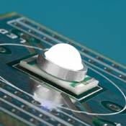
- Low heat generation
- High electrostatic discharge (ESD) tolerance/resistance
- Long life

For our customers, CREE® LEDs provide critical benefits, such as
- Super-bright light from little power
- Easy fit into tight places
- Simple thermal management
- Long product life / High Reliability
Figure 5 Cree Chip we use!

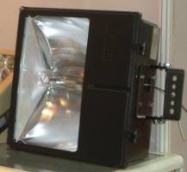
Figure 6 Before Lucas E40

Parts List:

Part Number | Description | Quantity | Parts Photos
6840-010-R1 | U-Tron Patented  Main Frame | 1 | 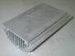 Figure 7
6840-020-R1 | Top Cover.  Available in multiple shades. | 1 | 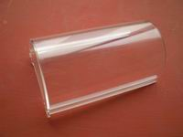Figure 8
6840-030-R1 | U-Tron Patented  Front Cover | 1 | 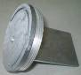 Figure 9
6840-040-R1 | U-Tron Patented  E40 Plastic Base | 1 | 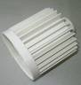 Figure 10
6840-050-R1 | Lens Cover | 1 | 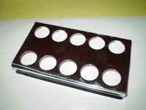 Figure 11
6840-060-R1 | U-Tron Patented  LED PCB Board | 1 | 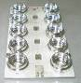 Figure 12
6840-070-R1 | E40 Base | 1 | 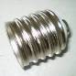 Figure 13
6840-080-R1 | Gasket | 2
6840-090-R1 | U-Tron Patented  Driver board | 1 | 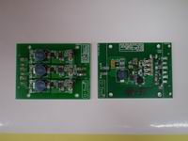 Figure 14
6840-100-R1 | Power Supply Board 20W | 1 | 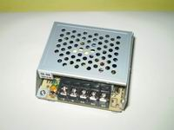 Figure 15
 | Long Screw | 2 | 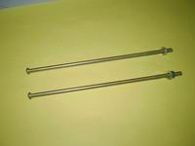 Figure 16

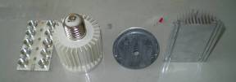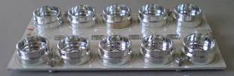

Parts can be purchased separately for our DIY enthusiasts!

Warranty:
U-Tron (Beijing) Electronics Co. Ltd., warrant the products listed bellow for a period of 36 months from the date of shipment to be free from defects in material or workmanship and to be of the kind and quality designated or specified in the purchase agreements. If any products dose not meets the above warranty and the buyer promptly files a warranty claim U-Tron shall do the following:
U-Tron shall provide a 12 months “No Questions Asked” replacement of any faulty units at no charge to the customer. The time limit for exchange shall not exceed 30 days from the time a claim is filed by the buyers. The buyers shall return the faulty units within 30 days of filing the claim. The method of shipping back the faulty units to U-Tron shall be decided at that time by U-Tron and all shipping charges shall be borne by U-Tron.
At the end of the 12 month period U-Tron shall provide additional free extended warranty for another 24 months. During this 24 months time U-Tron shall repair or replace and re-certify every faulty units returned. Shipping charges for sending the units to U-Tron shall be the responsibility of the Buyers and the Shipping charges to return the repaired goods to the buyer shall be borne by U-Tron. Time limit for repairs shall not exceed 60 days.
U-Tron at our own option can elect to provide replacement units at any desired percentage to be warehoused and logged by the buyers for timely service of the extended warranty replacements. When the warranty expires the bad units and the unused spare parts items shall be shipped back to U-Tron unless otherwise stipulated in the contract or purchase agreements. If the warehoused quantities become 90% used up or nearing the end of stock, the buyers shall ship back the faulty units to U-Tron. U-Tron shall rotate the spare parts inventory with in 60 days of receiving from the buyers.
All warranty claims items shall by shipped to the buyers regardless of the geographical location, by air freight to the nearest airport or courier service to the customer site, and any returning items can be shipped by sea or air freight at the request of U-Tron. If the customer fails to return the said faulty units with in the time frame as instructed, it will be considered as sold and U-Tron reserve the rights to bill the customer for its full value.
U-Tron shall not bare any responsibilities with the buyers customer claims or shall not bare any other expenses incurred other than the units cost it self. Customer site un-installation and re-installation of any faulty units shall not be the responsibilities of U-Tron.
The warranties set forth herein shall be voided if the units have been 1) repaired or altered by any un-authorized person 2) subjected to misuse, negligence and accidents or operated in other than normal operation and use. 3) Connected, installed or modified in a manner not in accordance with U-Tron instructions.
This warranty is applicable to all LED Products.

